**Practical No 9**

**Aim: Study of Deployment** **Diagram**

Deployment Diagram is a type of diagram that specifies the physical hardware on which the software system will execute. It also determines how the software is deployed on the underlying hardware. It maps software pieces of a system to the device that are going to execute it. The deployment diagram maps the software architecture created in design to the physical system architecture that executes it. In distributed systems, it models the distribution of the software across the physical nodes. The software systems are manifested using various artifacts, and then they are mapped to the execution environment that is going to execute the software such as nodes. Many nodes are involved in the deployment diagram; hence, the relation between them is represented using communication paths. There are two forms of a deployment diagram Descriptor form and Instance form. Deployment diagrams are used with the sole purpose of describing how software is deployed into the hardware system. It visualizes how software interacts with the hardware to execute the complete functionality. It is used to describe software to hardware interaction and vice versa.

**Notation For Deployment** **Diagram:**

* **Node:** Node is a computational resource upon which artifacts are deployed for execution.
* **Communication Association:** This is represented by a solid line between two nodes. It shows the path of communication between nodes.
* **Artifact:** Artifacts are concrete elements that are caused by a development process.
* **Devices:** A device is a node that is used to represent a physical computational resource in a system.
* **Deployment Specifications:** Deployment specifications is a configuration file, such as a text file or an XML document. It describes how an artifact is deployed on a node.

**When to use:**

Deployment diagrams are mostly used by system administrators, network engineers, etc. These diagrams are used with the sole purpose of describing how software is deployed into the hardware system. It visualizes how software interacts with the hardware to execute the complete functionality. To make the software work efficiently and at a faster rate, the hardware also must be of good quality. It must be designed efficiently to make software work properly and produce accurate results in quick time.

Deployment diagrams can be used for:

1. Modelling the network topology of a system.
2. Modelling distributed systems and networks.
3. Forward and reverse engineering processes.

Consider a University Database that keeps track of the student and their majors, transcripts and registration and the university course. Several sections of each course are offered and each section is related to the instructor who is teaching. It also keeps track of sponsored research projects of faculty and graduate students of academic departments of the particular college. The database also keeps track of the research grants and contracts awarded to the university. A grant is related to one principle investigator and to all researchers it supports**.**

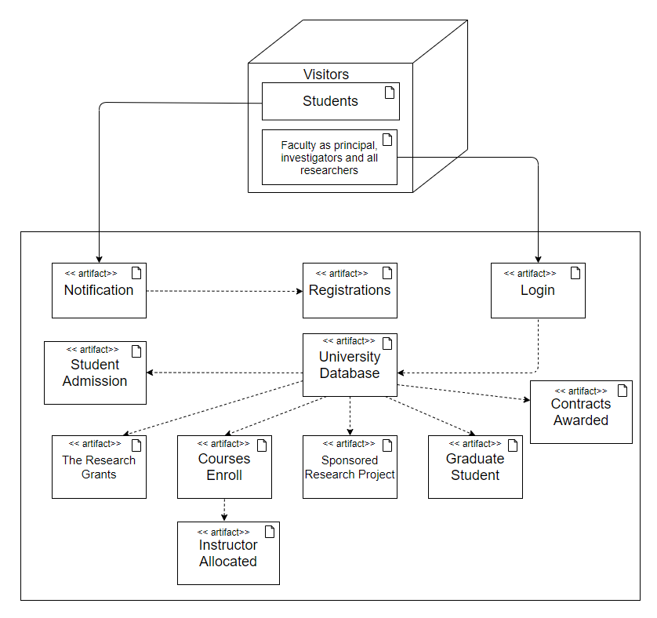

**Conclusion: We have studied the details about the deployment** **diagram.**